April 26, 2012

The Executive Committee of University Council met on April 12th in the Peabody Board Room of the Administration Building. After declaring a quorum and approving the minutes, the Committee approved the new appointments to the Program Review and Assessment Committee. The Committee elected Silvia Giraudo as the Chair-Elect for 2012/2013 academic year.

The committee then voted to place 11 items from the University Curriculum Committee on the April 26th University Council agenda. The Statutes and Bylaws Committee also provided the second reading for the proposed changes in the University of Georgia Statutes and Bylaws for the next Council meeting.

The meeting was adjourned.

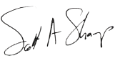

Scott A. Shamp
Chair
Executive Committee of University Council

