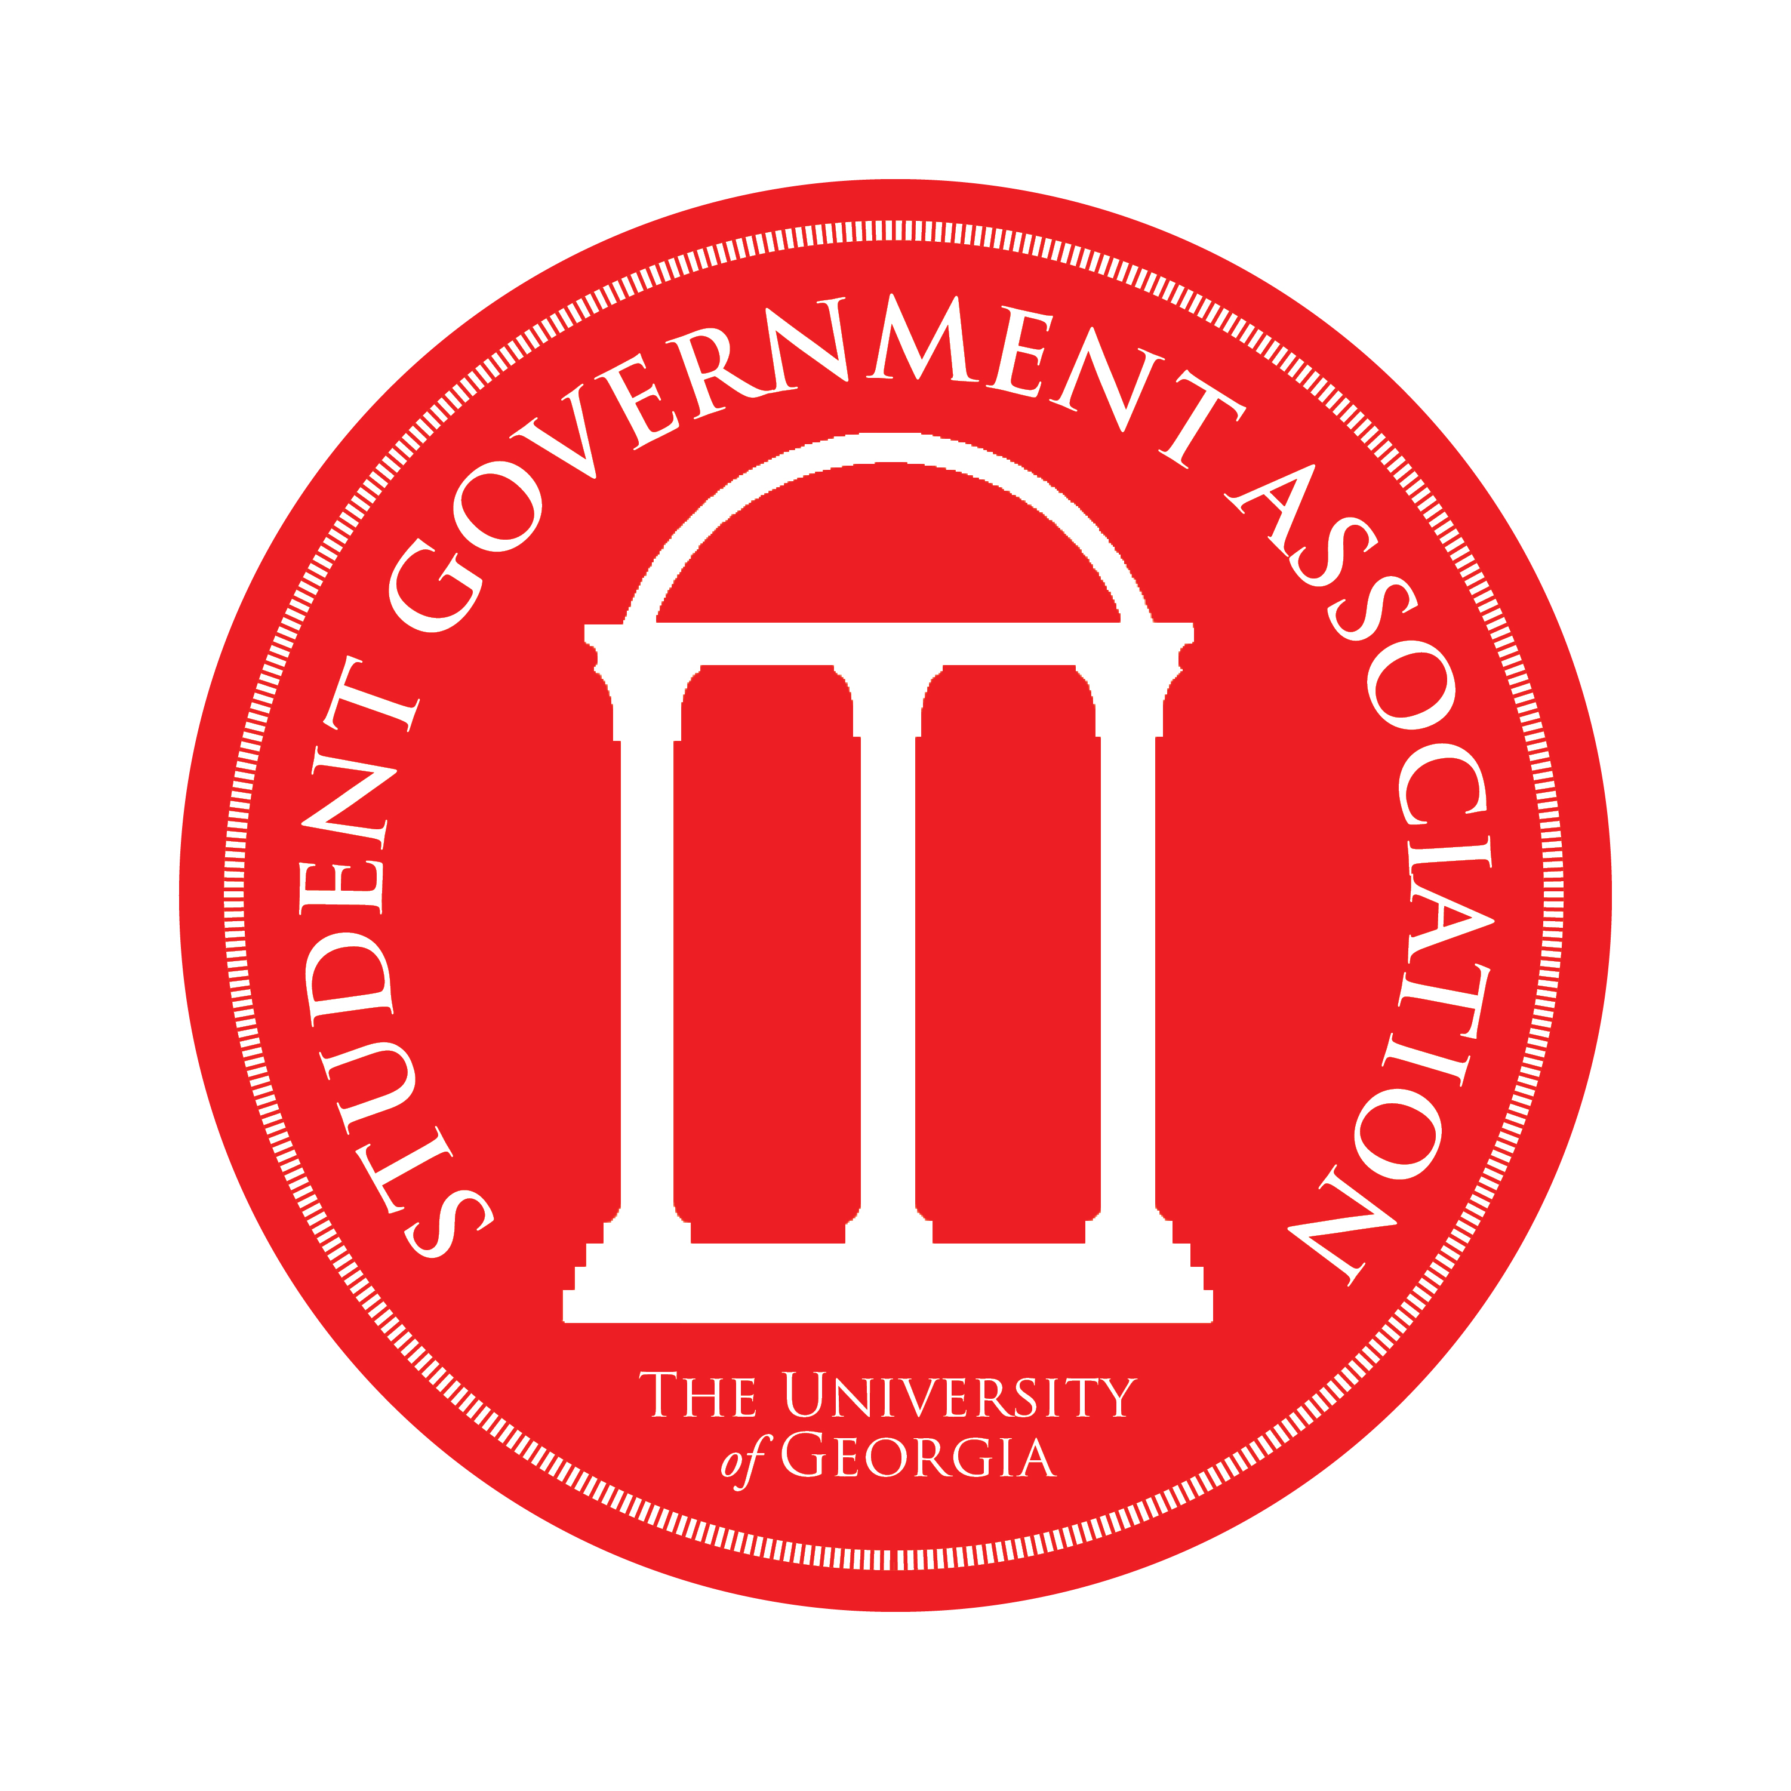
Student Government Association
University Council Report
April 2012

- Successful 150th Anniversary of Morrill Acts Event
- Completed All Campus Allocations process
  - $1,746,764 to campus programming
  - $230,438 to schools and colleges (based off formula)
- Hello, Okefenokee Oar display!
- SOAR Award – Best Large Campus Event for Freshman Welcome
- Elections
  - Runoff!
  - Grand total of approximately 7,900 total votes cast
  - Meet Will Burgess, President-Elect
If there are any questions regarding the nature of these items or the Student Government Association in general, please direct those to ugasgaexec@gmail.com

