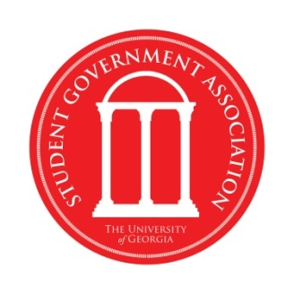
Senate Resolution 24-04

To express condemnation of the Board of Regents decision to ban undocumented students from applying to the University of Georgia and for other purposes

Authored and Sponsored by Senator Logan Krusac, At-Large Student Life Representative

WHEREAS, the Board of Regents has voted to exclude all undocumented immigrants from Georgia’s top five universities; and

WHEREAS, equal opportunity and education are quintessential American values; and

WHEREAS, the Board of Regents’ mission statement claims, “Each institution in the University System of Georgia will be characterized by cultural, ethnic, racial, and gender diversity in the faculty, staff, and student body, supported by practices and programs that embody the ideals of an open, democratic, and global society;” and

WHEREAS, all three of the Board of Regents’ concerns regarding undocumented students were refuted by their own October 2010 investigation; and

WHEREAS, undocumented immigrants make up only .16% of students in the University System; and

WHEREAS, all undocumented immigrants pay out-of-state tuition; and

WHEREAS, no evidence exists to show that undocumented students are taking places of equally qualified Georgia students; and

WHEREAS, a student qualified to attend one of Georgia’s top five universities will be denied admission and discriminated against only as a result of his or her immigration status; and

WHEREAS, the ban encourages intolerance of others based on one’s immigration status.

NOW, THEREFORE BE IT RESOLVED BY THE SENATE that we, the Student Government Association of the University of Georgia, in our responsibility to represent the student body of the University of Georgia, hereby condemn the ban preventing undocumented students from applying to the University of Georgia.

BE IT FURTHER RESOLVED that the Student Government Association urges the Board of Regents to repeal this ban and allow all students to apply to all of Georgia’s institutions of higher education.

